What EVERY Sophomore @ SMHS should know!

### What you should be doing NOW!

#### Research colleges, technical schools and/or the military ~ Meet with the Career Center Specialist ~ Explore Careers ~ Apply for NHS ~ Align Courses to Future Goals ~ Prepare for important tests

# College and Career Information Resources

|  |  |  |
| --- | --- | --- |
| Resources | How to access | Description |
| Major Clarity | In educational resources on PUSD student portal | Career Interest inventories, career information, college information |
| ACT | [www.act.org](http://www.act.org) | Prepare to take this your junior year  practice tests available online |
| SAT | [www.collegeboard.org](http://www.collegeboard.org) | register online  scholarships, colleges  financial aid |
| Fastweb | [www.fastweb.com](http://www.fastweb.com) | Internet’s largest free scholarship resource |

### College and Career Testing Information

|  |  |  |
| --- | --- | --- |
| Test | Date(s) | Take Note! |
| ASVAB | Spring of your Junior year  (See the Career Center Specialist to sign up) | A Vocational Aptitude Battery, administered by the military. A valuable test regardless of whether you are planning on enlisting in the military. You will learn about military and civilian careers that would be a good fit. |
| SAT & PSAT  [www.collegeboard.org](http://www.collegeboard.org) | PSAT is offered at SMHS in the Fall of your Junior Year. | PSAT prepares students for SAT tests. Must take this test to compete for some National Scholarships. SAT exams are accepted by most colleges and universities. Check your school of interest. |
| ACT  [***www.act.org***](http://www.act.org) | ACT is taken by ALL juniors at SMHS during the Spring of your junior year for free. | Accepted by most colleges and universities. Check your schools of interest. If you need to ***re-test*** go to [www.act.org](http://www.act.org) **Sign up deadline is 5-6 weeks prior to test date.** |
| Community College Placement tests  **https://www.maricopa.edu/future-students/placement-coach** | Spring of your senior year (some placement tests are taken during high school for dual enrollment classes) | Placement exam for Community College |

Important Deadlines To Remember

|  |  |
| --- | --- |
| Item | Deadline |
| Priority deadline West-MEC Application | December 16th, 2022 |
| **LAST DAY** to change course requests for your Junior year | Feb 14th, 2023 |
| ACT/SAT Registration | At least one (1) month prior to test date  **Should be taken in the Spring of your junior year**. Retake if necessary. |
| Private Scholarships | Deadlines vary **junior** and **senior** year. |
| Class Rank | Class Rank sent to colleges/universities for scholarship purposes at the end of Junior Year |

### Ways to Get Caught Up On Lost Credit

|  |  |
| --- | --- |
| Additional Credit Opportunity | Description |
| Summer School Credit Recovery  e-Campus Online | 1 credit/summer – cost to be determined  1 credit - $300.00 |
| Community Service | ½ credit/60hrs worked – FREE |
| P.A.S.S. Program | Afterschool program -- $75.00/ .5 credit |
| Online Courses | Several options – see your counselor |
| **More information on all of these programs is available at the Guidance Office**. | |

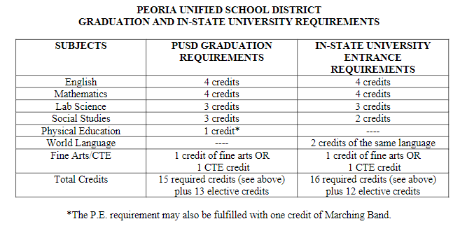

Course Offering Guide can be found at <https://isapps.peoriaud.k12.az.us/coursedescriptionguide>

Course Requests can be viewed through your StudentVUE

LAST DAY TO REQUEST CHANGES WILL BE Feb. 14th, 2023!

**Have questions? Make an appointment with your counselor.**